HOW TO SOLVE THE MATHEMATICAL PROBLEMS IN YOUR SCIENCE SUBJECT
QUANTITY | SYMBOL | UNITS
Distance | d | metres, m
Displacement | s | metres, m
Time | t | seconds, s
Speed | S | metres/second,  m/s
Velocity | v | metres/second,  m/s
Acceleration | a | metres/sec/sec,  m/s²
Initial Speed | S_{i} | m/s
Final Speed | S_{f} | m/s
Initial velocity | v_{i} | m/s
Final velocity | v_{f} | m/s
Kinetic Energy | KE | joules, j
Mass | m | kilograms, kg
Gravitational Potential Energy | GPE | Joules, J
Force | F | newtons, N
Height | ht | metres, m
Gravity | g | 9.8 m/s²

STEP 1 - Identify exactly what the question if asking you to find (or calculate, or determine). Circle this and label it with the correct letter (from the list on the right) and a question mark.

STEP 2 - Write down a formula for this letter. Look at the bottom of the page for the formula triangles.

STEP 3 – Look at the other letters in the formulas. The value (numbers you need) for each letter should be in the question. Find each one and label it with its correct letter.

STEP 4 - Check that the values (from step 3) have the correct units you need for your calculation (see the list on the right). Do unit conversions for any which are not in correct units (see below for unit conversions)

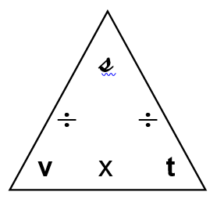
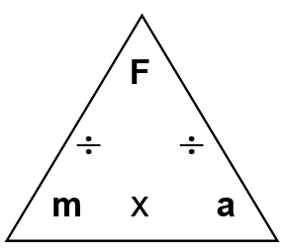
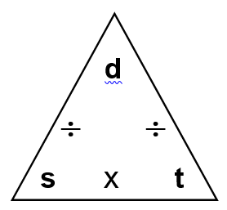
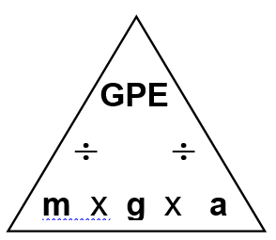
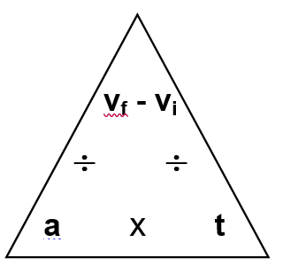
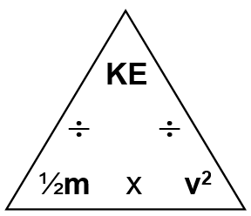
STEP 5 - When all the units are correct, write the values into the formula, and calculate your answer. Write the correct units with your answer
Formulas

metres
kilometres
÷ 1000
x 1000
grams
kilograms
÷ 60
x 60
÷ 3600
x 3600
÷ 60
x 60
tonnes
m / s
km / hr
X 3.6
÷ 3.6
seconds
minutes
÷ 60
x 60
÷ 3600
x 3600
÷ 60
x 60
hours
Unit conversion
EXAMPLE
Bronwyn was running late for a job interview. She had 4 kilometres left to drive and only 3 minutes left to get there. If the speed limit was 80 km/hr, could she make it without breaking the speed limit?

Solution:
STEP 1 - There are several ways to do this problem using the steps above, all of which are correct. Your teacher may model the other ways to you, but I think this question is asking me to calculate Bronwyn’s speed and compare it to 80 km/hr.
Bronwyn was running late for a job interview. She had 4 kilometres left to drive and only 3 minutes left to get there. If the speed limit was 80 km/hr, could she make it without breaking the speed limit?

s ?

s = d
t

STEP 2 -

Bronwyn was running late for a job interview. She was stuck in traffic, and when it finally cleared she had 4 kilometres left to drive and only 3 minutes left to get there. If the speed limit was 80 km/hr, could she make it without breaking the speed limit?

t
s ?
d
STEP 3 -

X 1000
STEP 4 - d, distance should be in metres – km −−−−−−→ m therefore d = 4 x 1000 = 4000 m
X 60
t, time should be in seconds – min −−−−→ sec therefore t = 3 x 60 = 180 sec

S = 22.2 m/s

S = 4000 m
180 s

STEP 5 –

EXTRA STEP – compare Bronwyn’s speed to speed limit of 80 km/hr. Convert 22.2 m/s to km/hr by multiplying by 3.6
22km/s x 3.6 = 79.9 km/hr
Bronwyn’s speed exactly matches the speed limit of 80 km/hr, meaning in theory she does not have to break the speed limit to make the interview on time.

